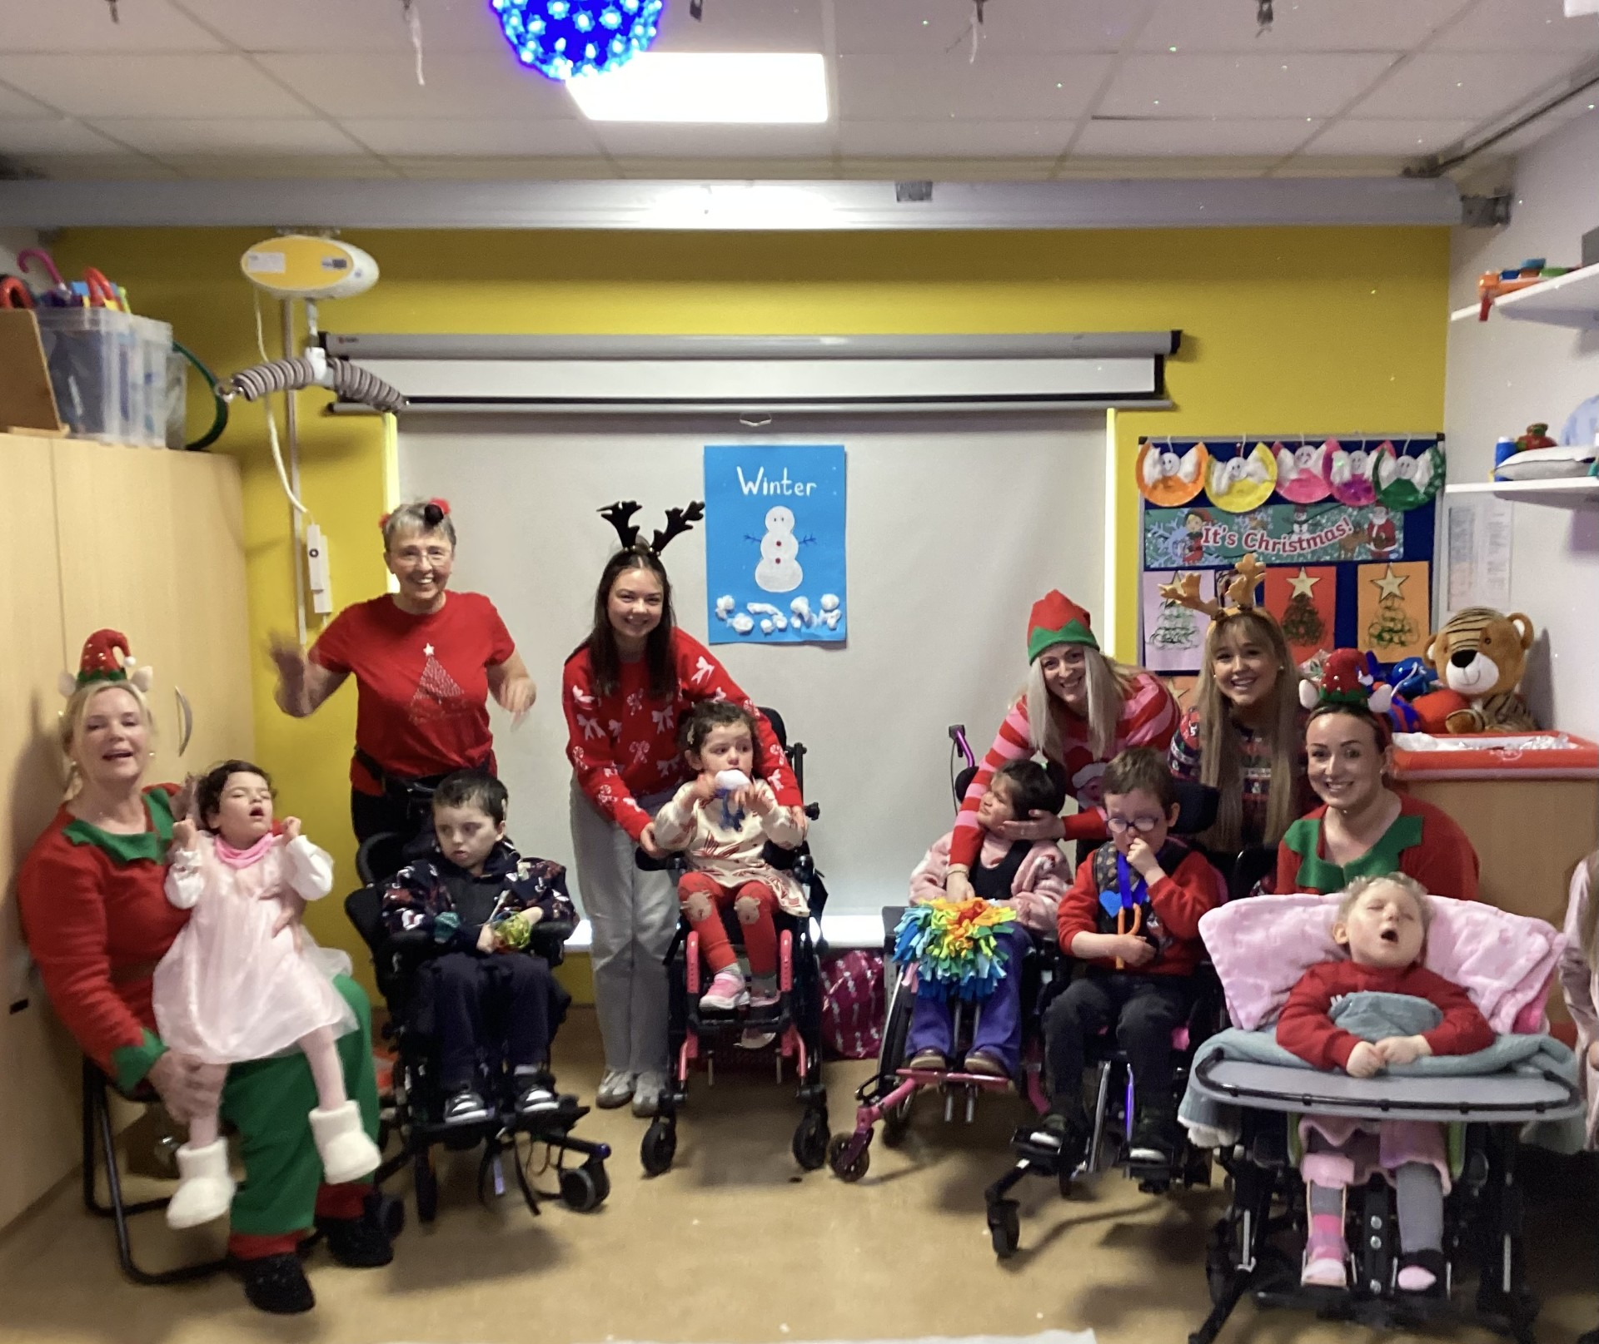
Burren View

News
2025-26

A New Year Begins
After a very busy July programme, we were back to school for a new term, and are delighted to welcome Megan as our teacher and Josephine as our SNA and bus escort  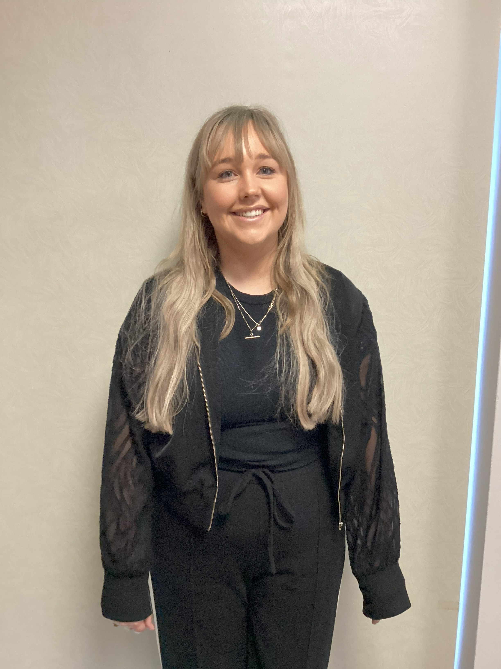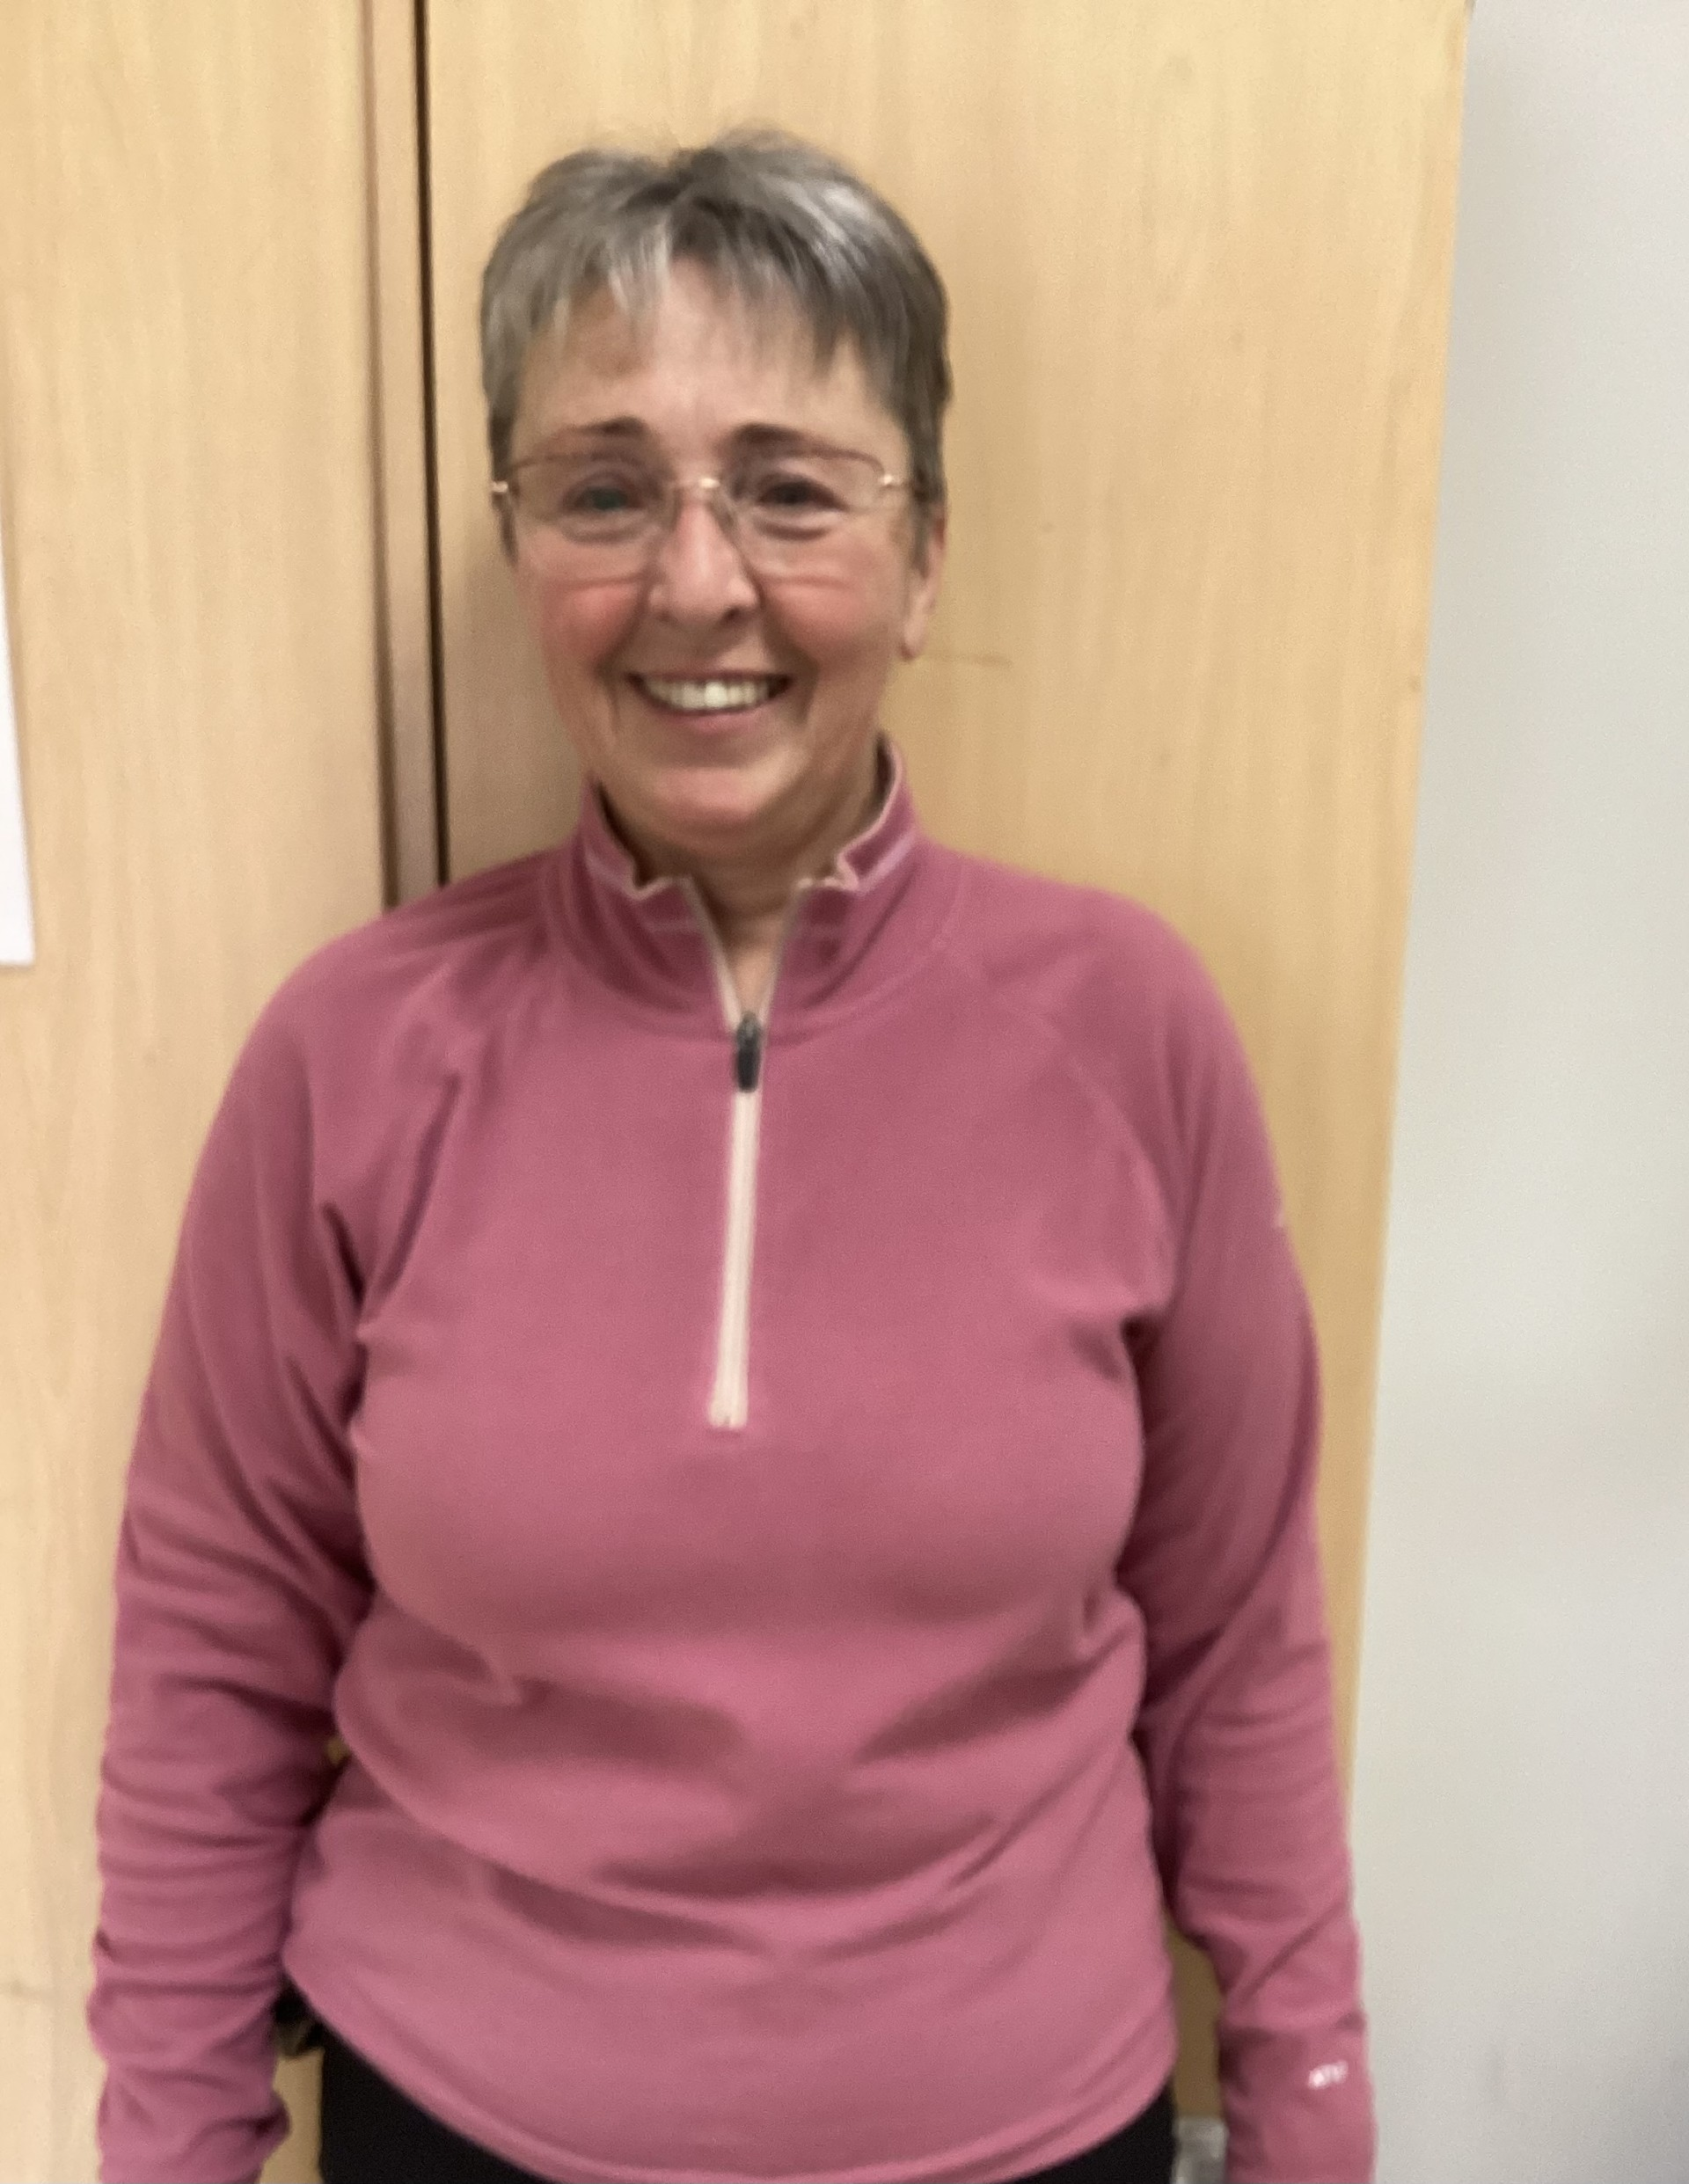  We also welcome our new friend Yeva; Lilly, James, Senán, Erin and Ruby have helped her to settle in especially during circle time. As always we hit the ground running, with classroom activities, swimming, baking, social outings and walks in the locality when the weather would allow.  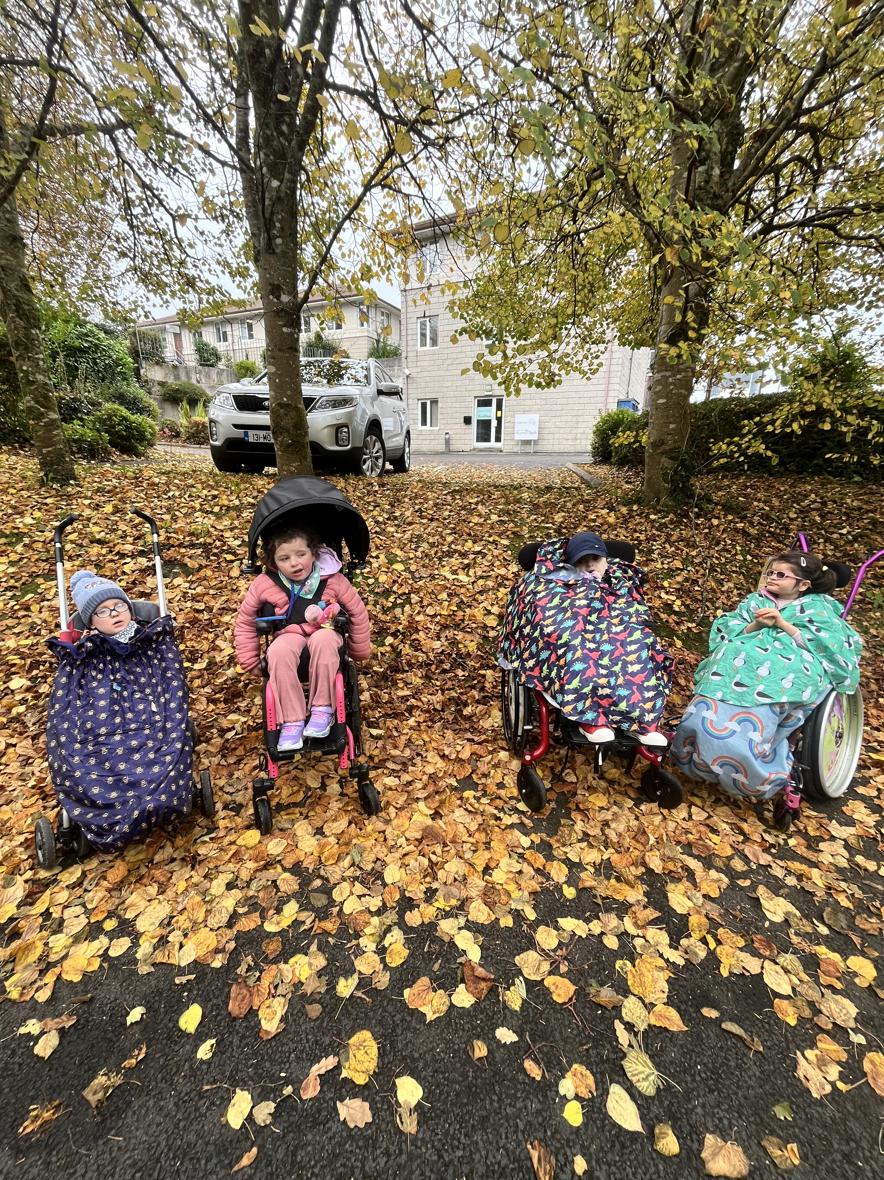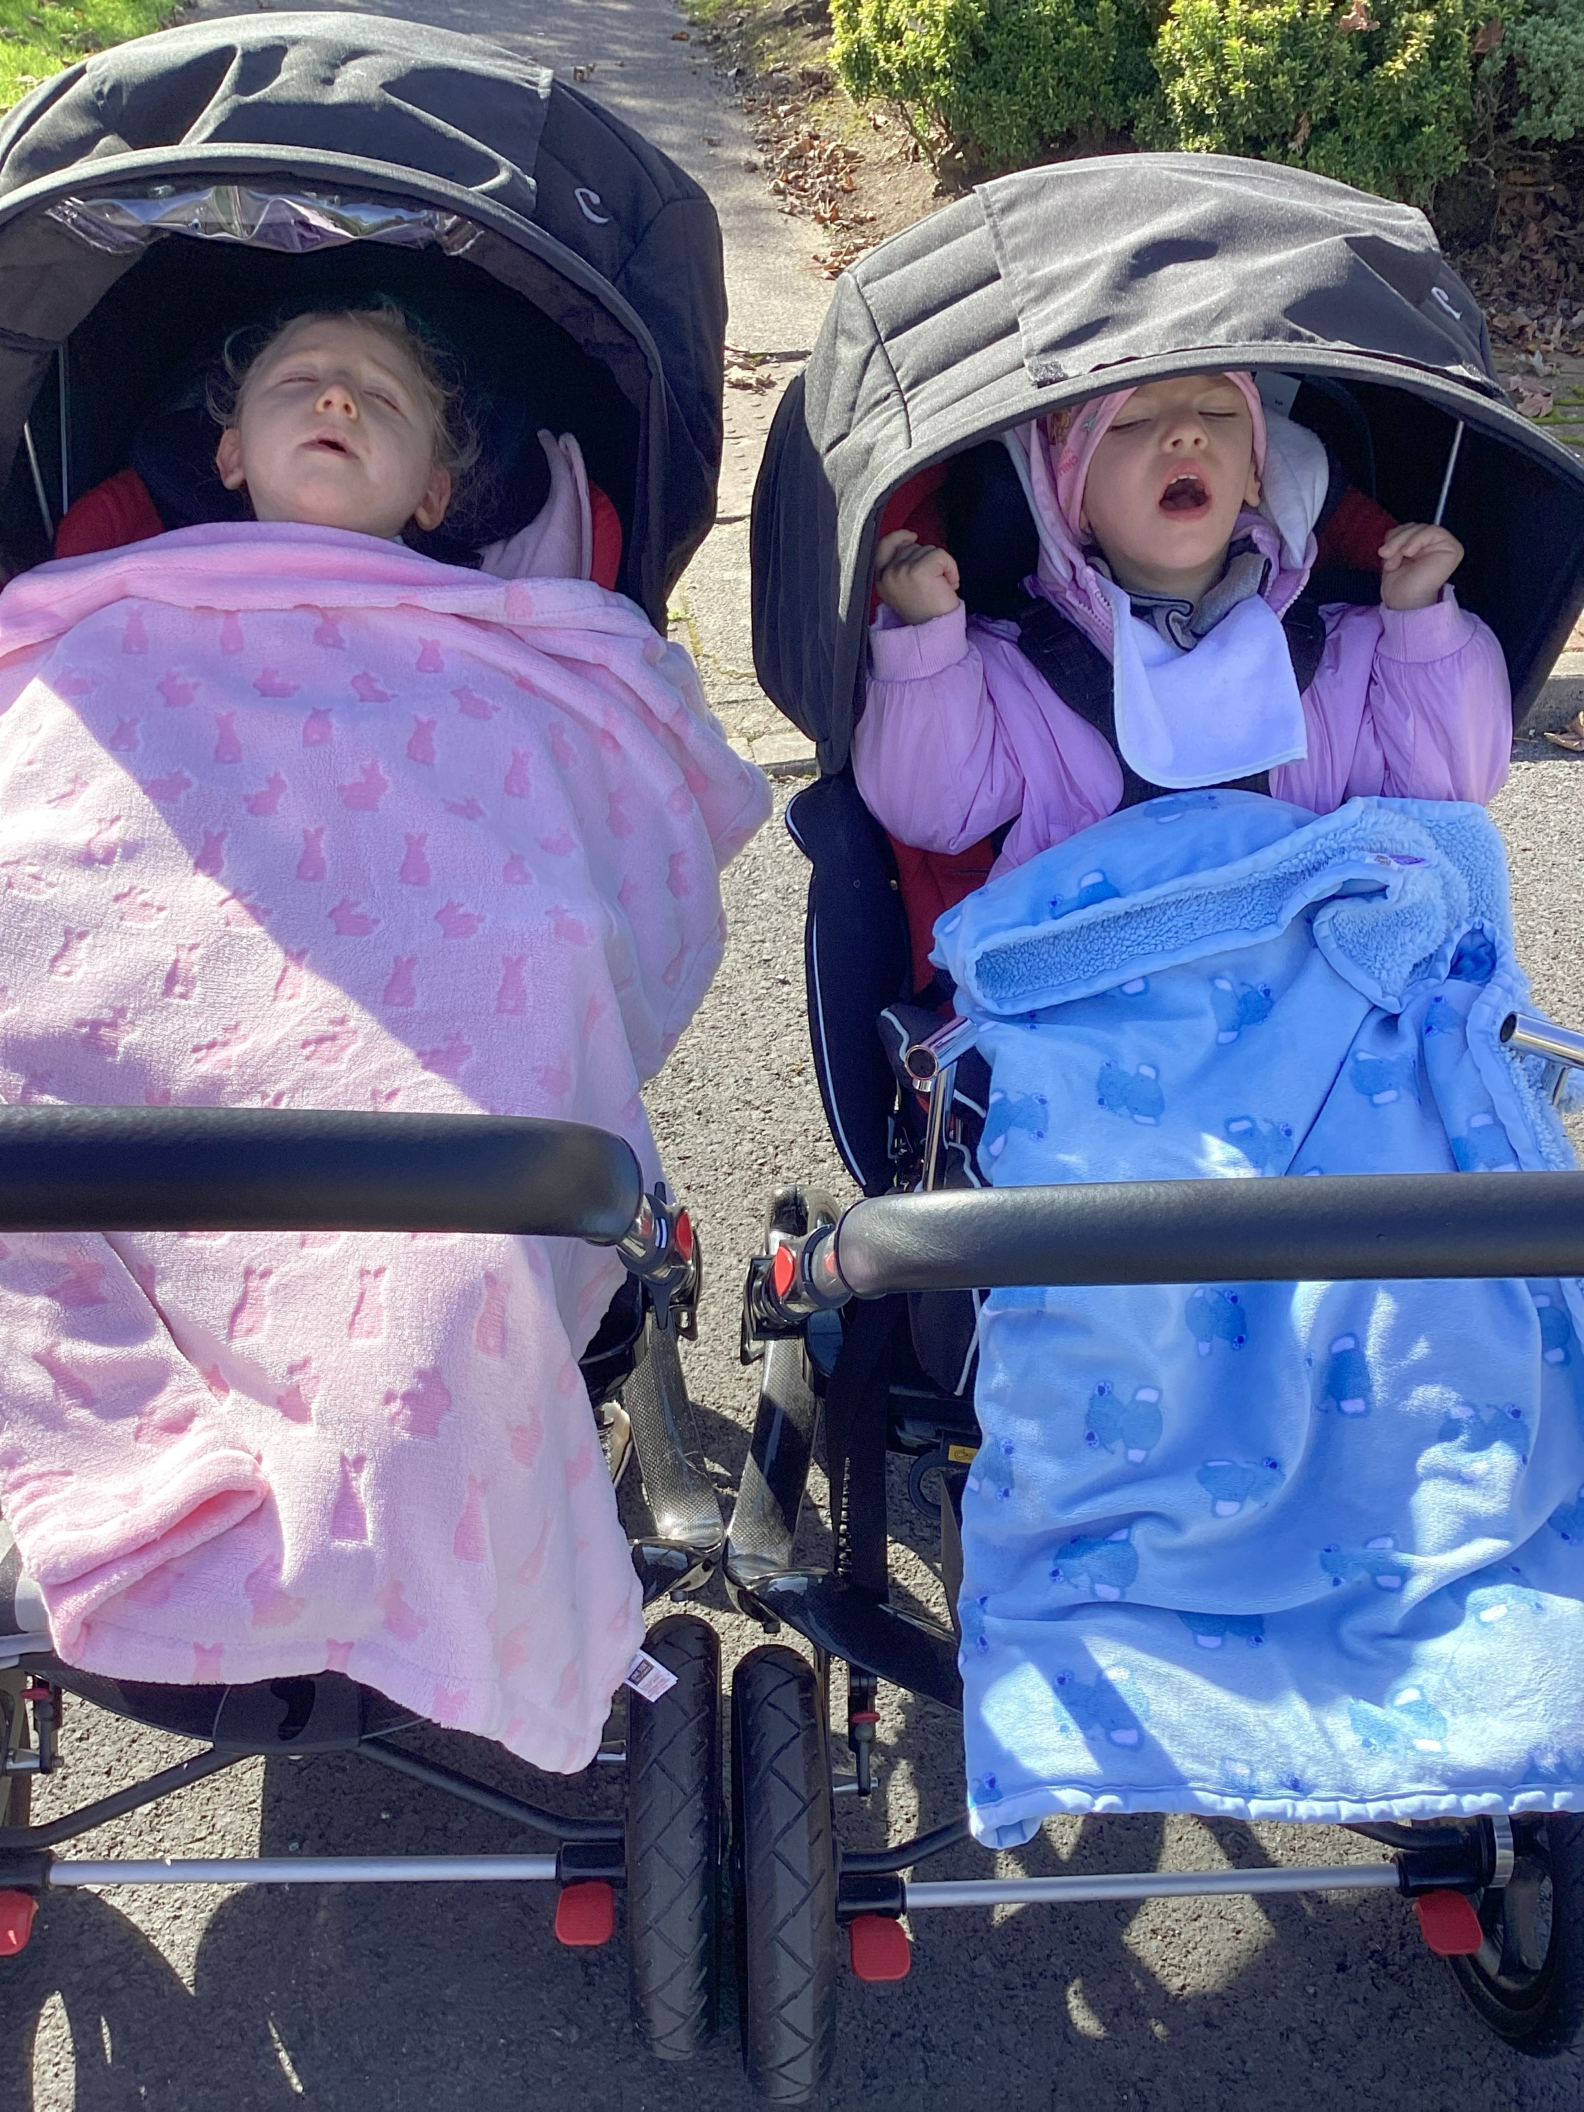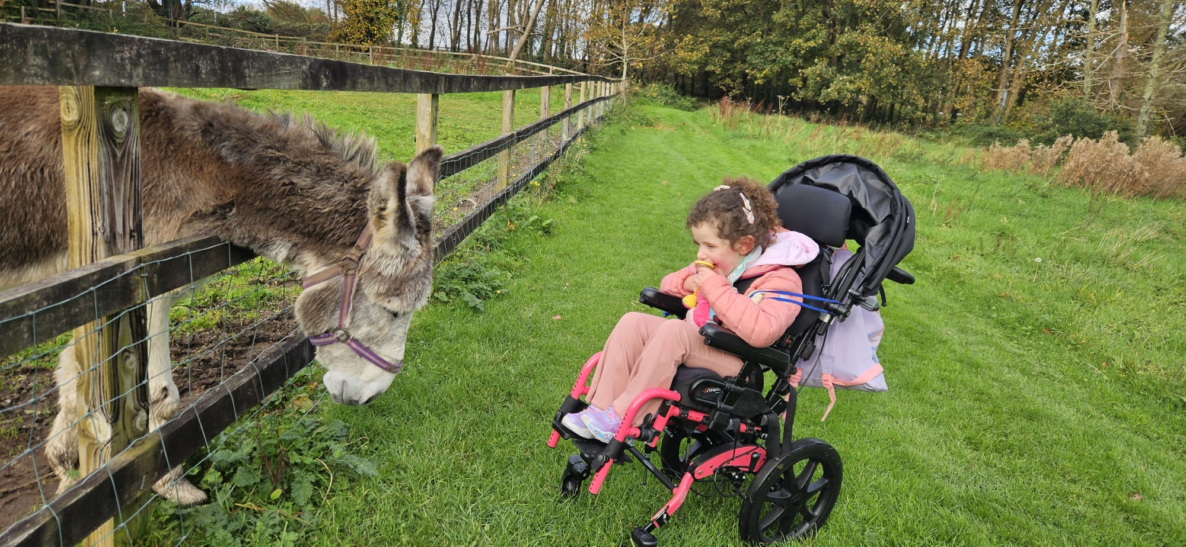  Our first celebration of the new year was Halloween, and before we knew it, it was Christmas. We enjoyed our first family day as we came together to enjoy our sensory Christmas. |  | Welcome Yeva    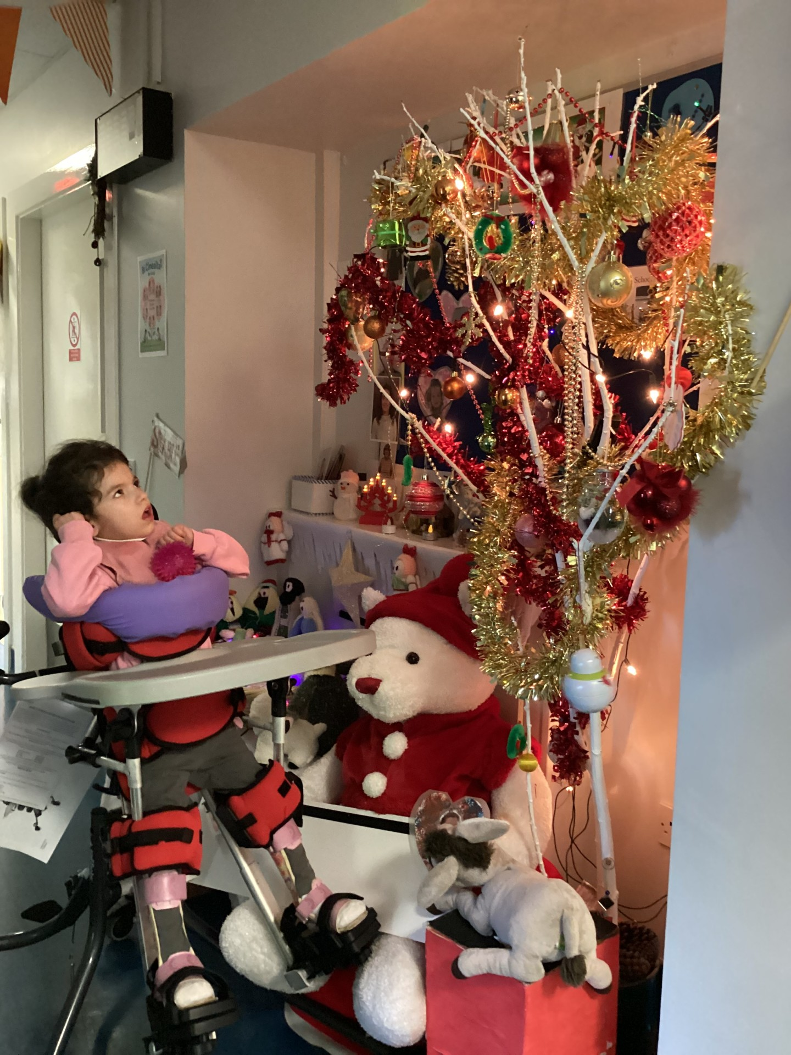  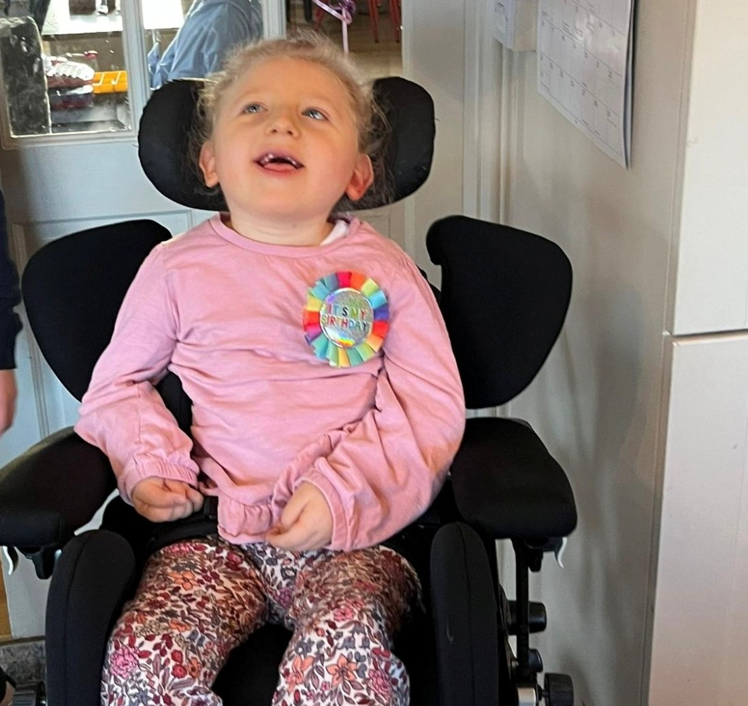
We have had 4 birthdays so far this year, and we were busy baking and celebrating!

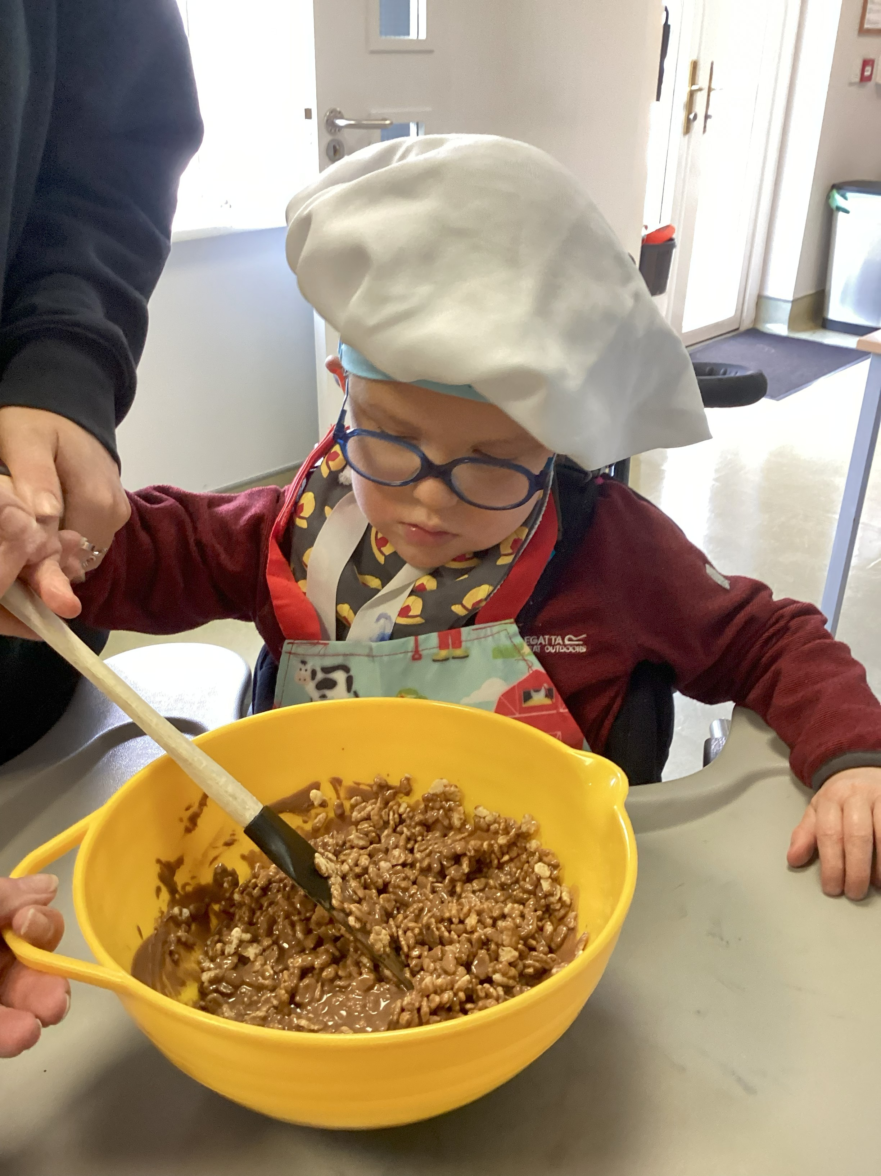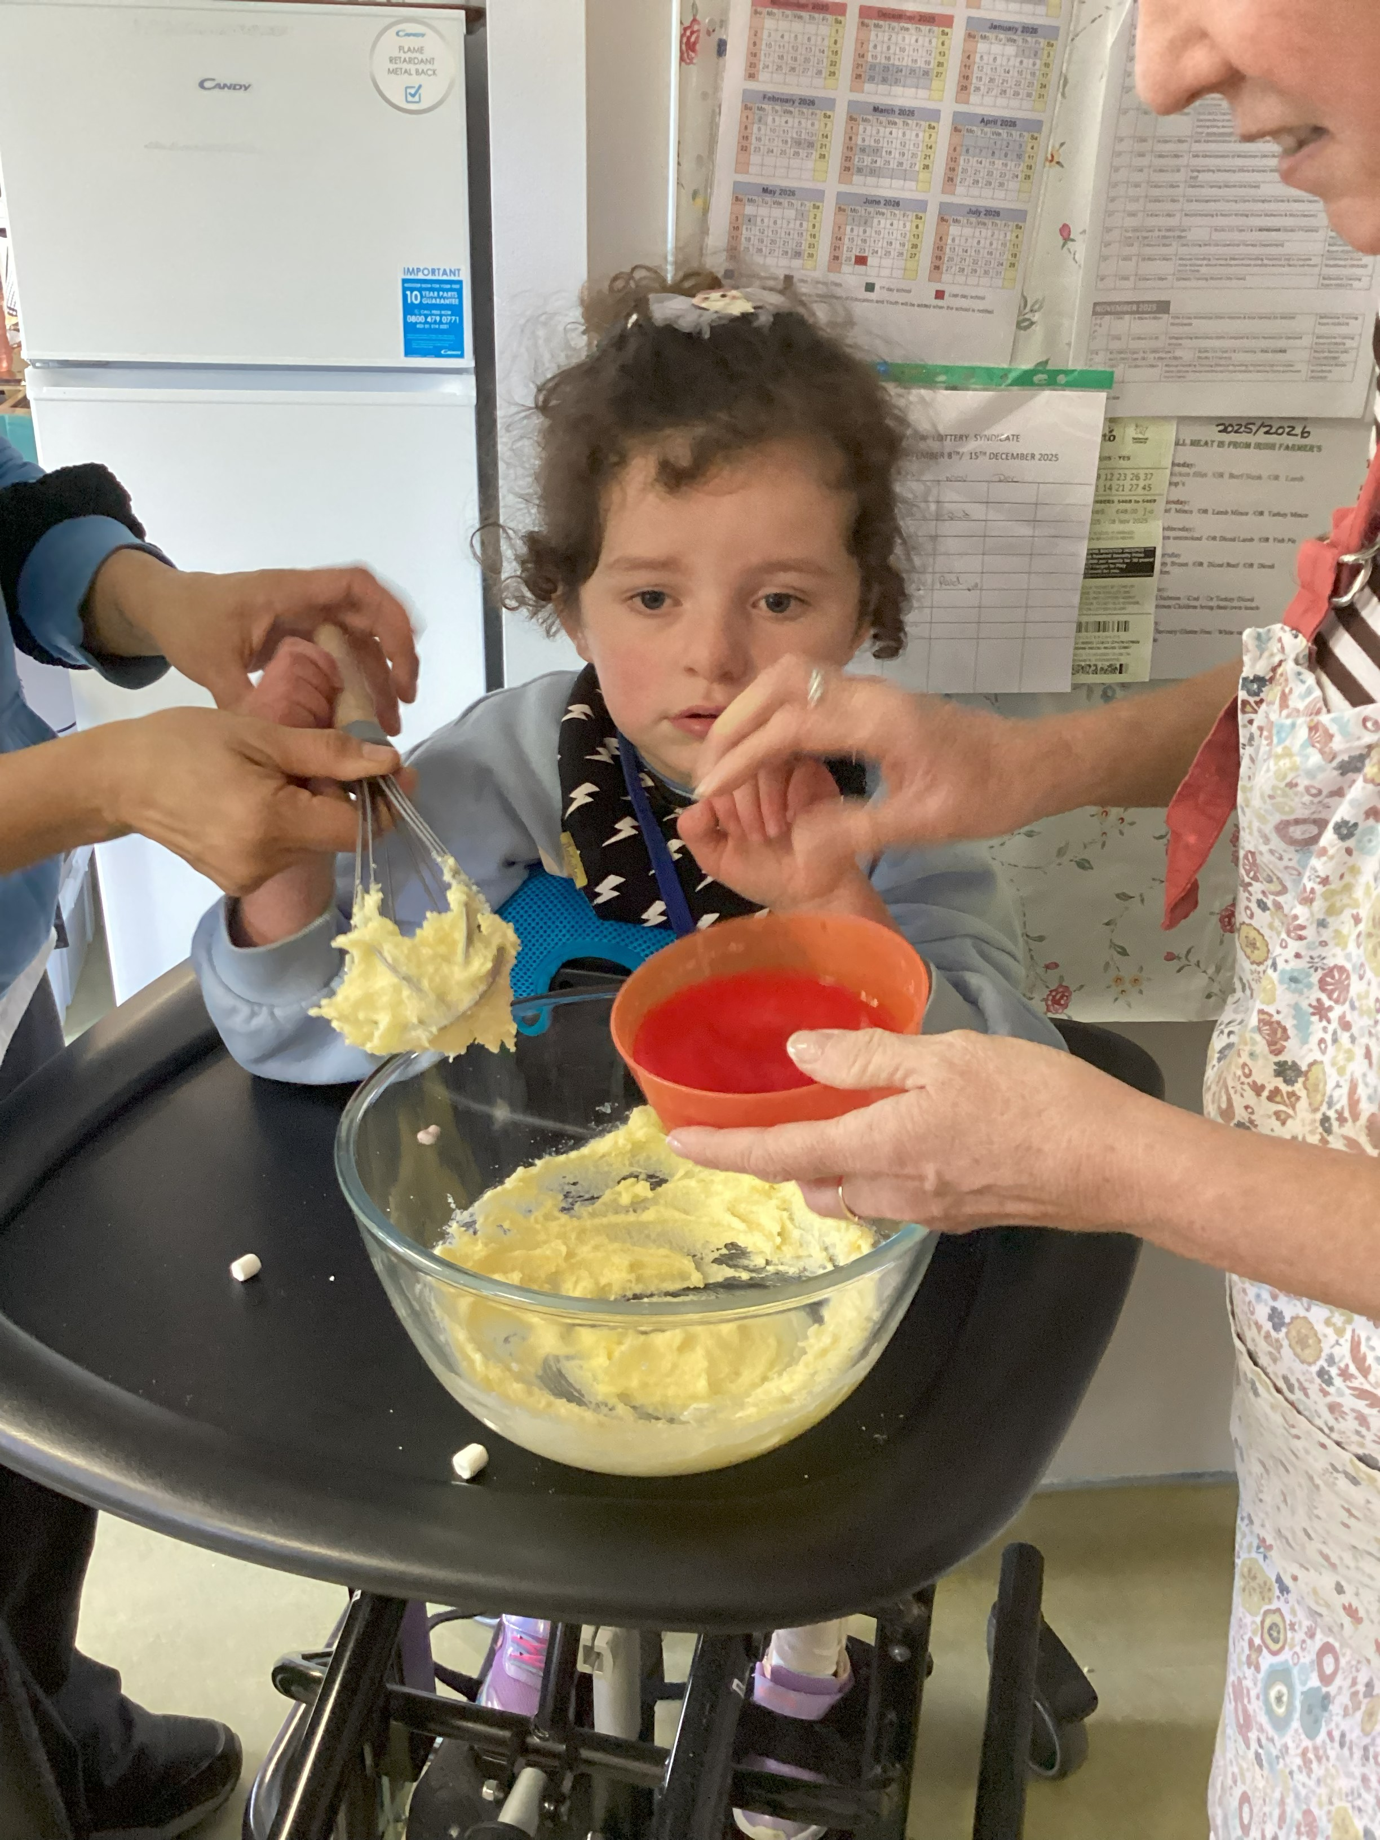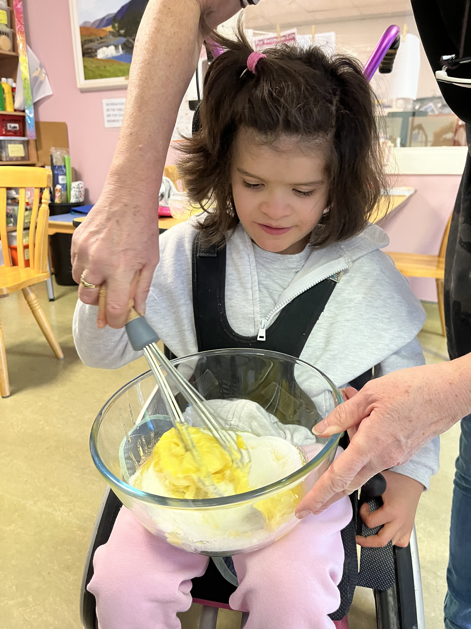

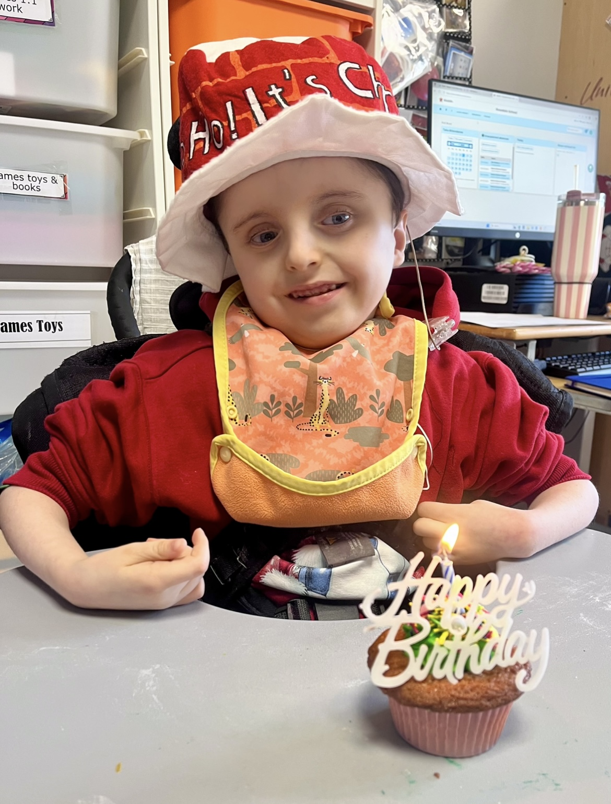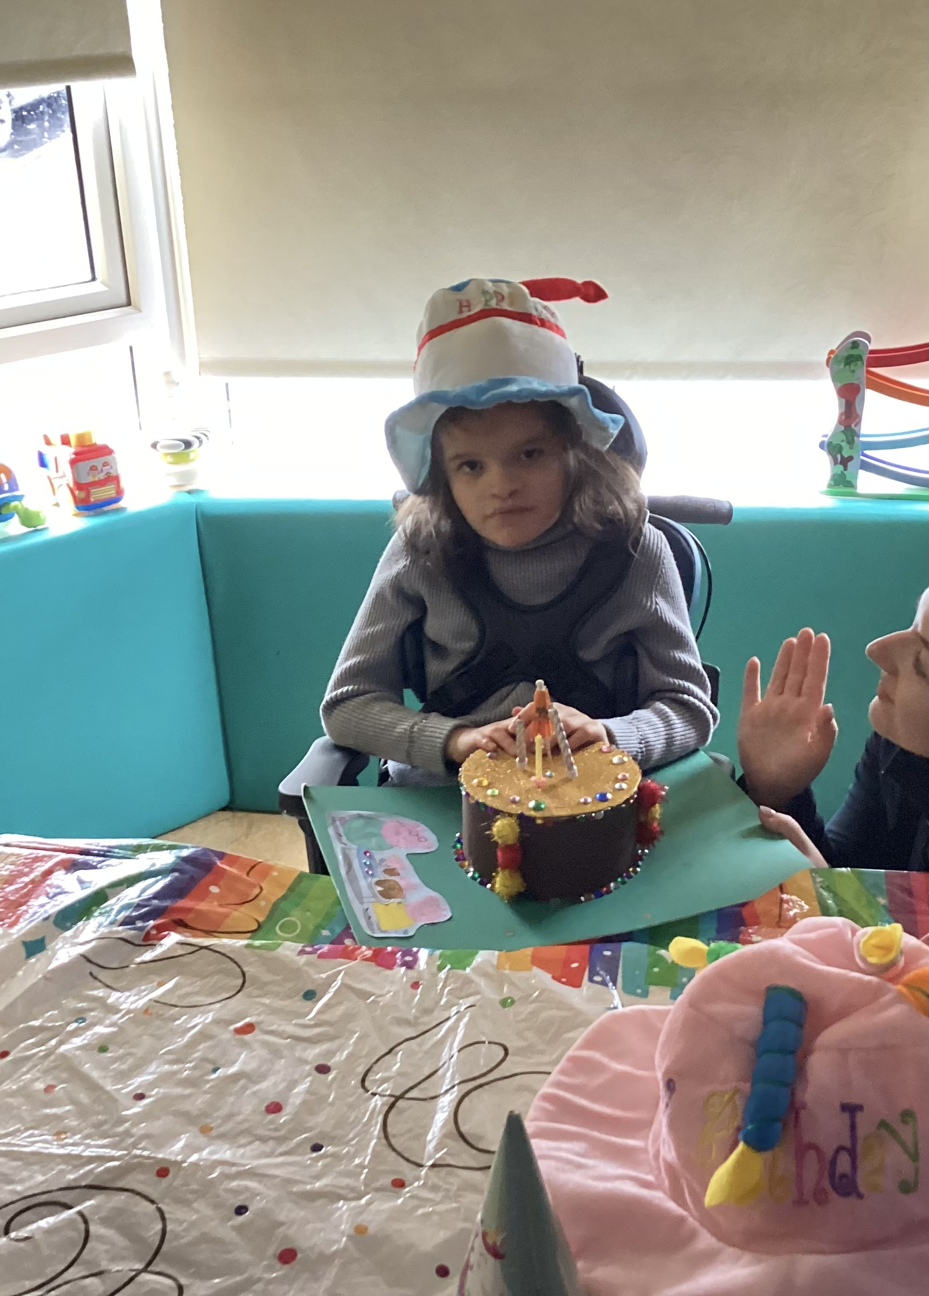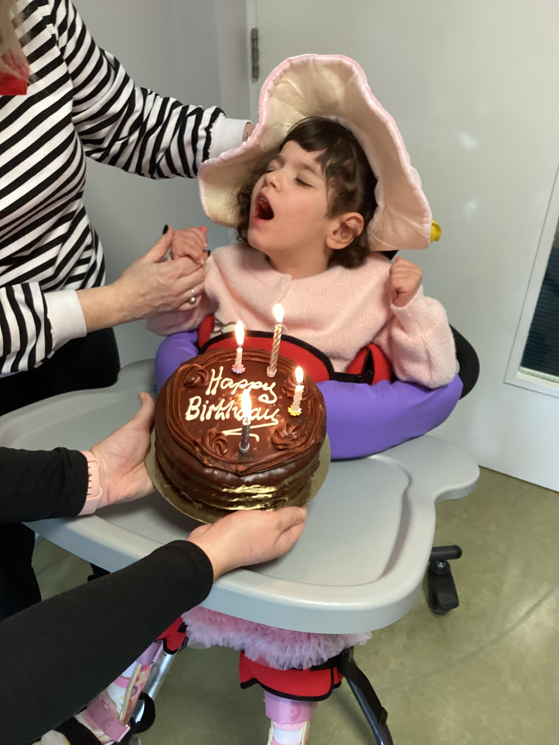

Art was a big focus for us this term, especially in preparation for Christmas

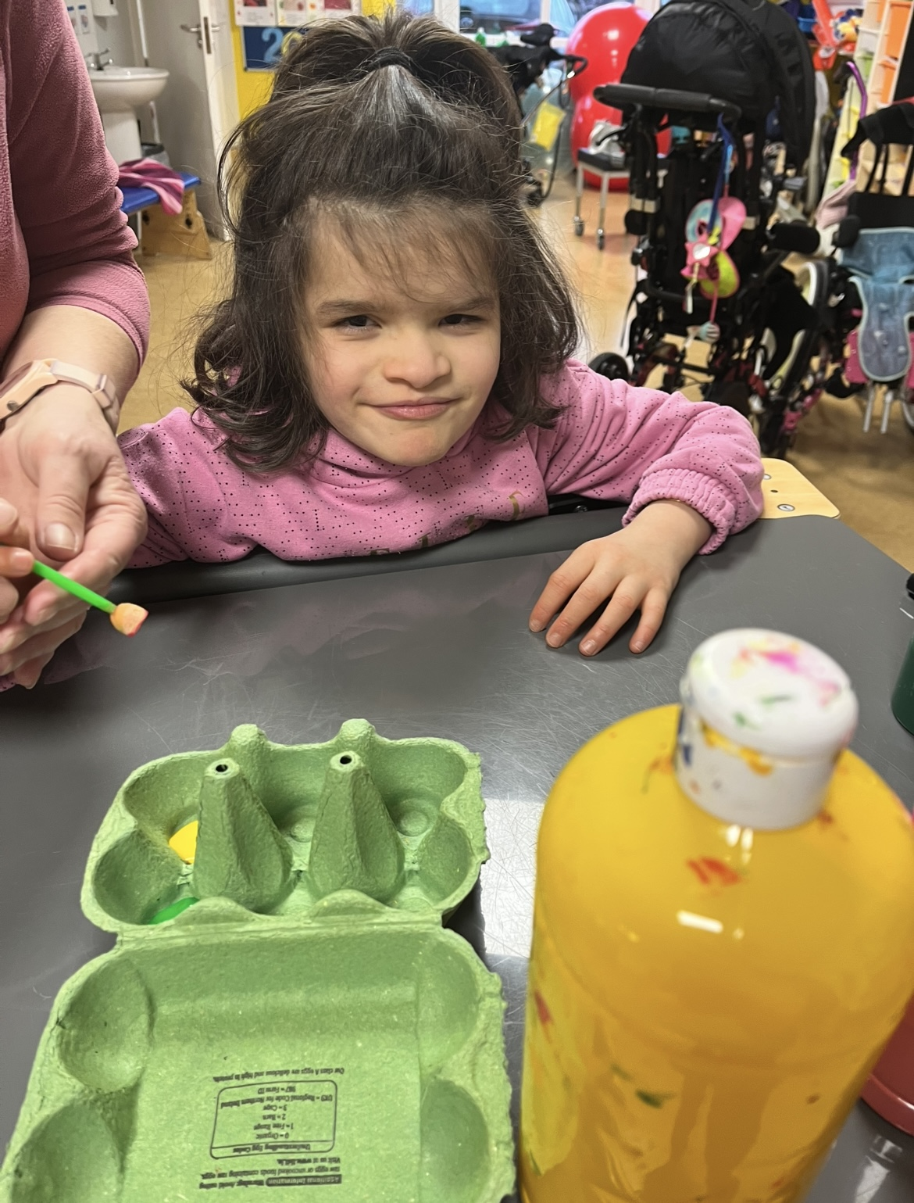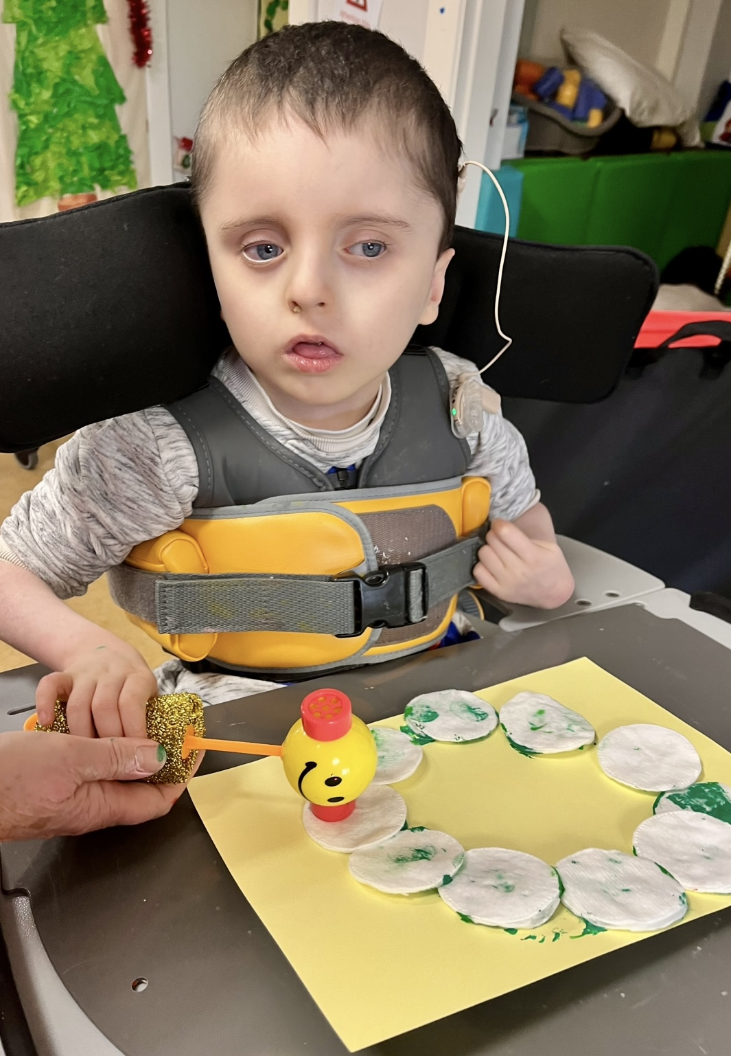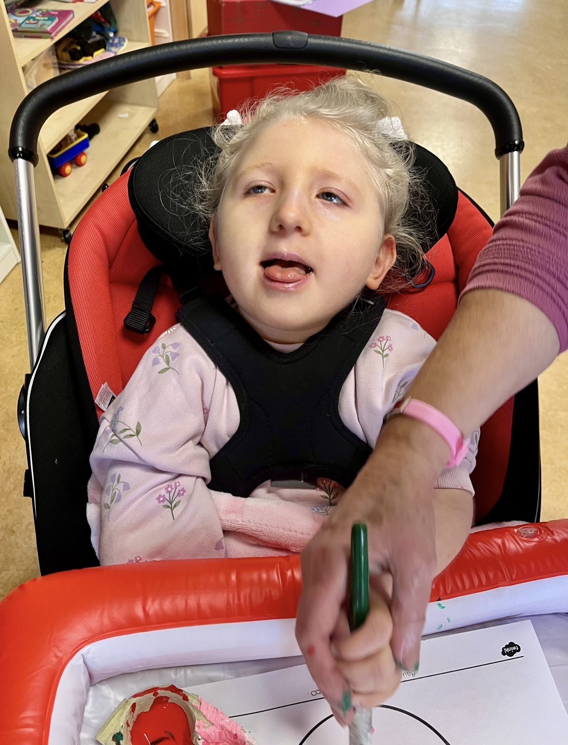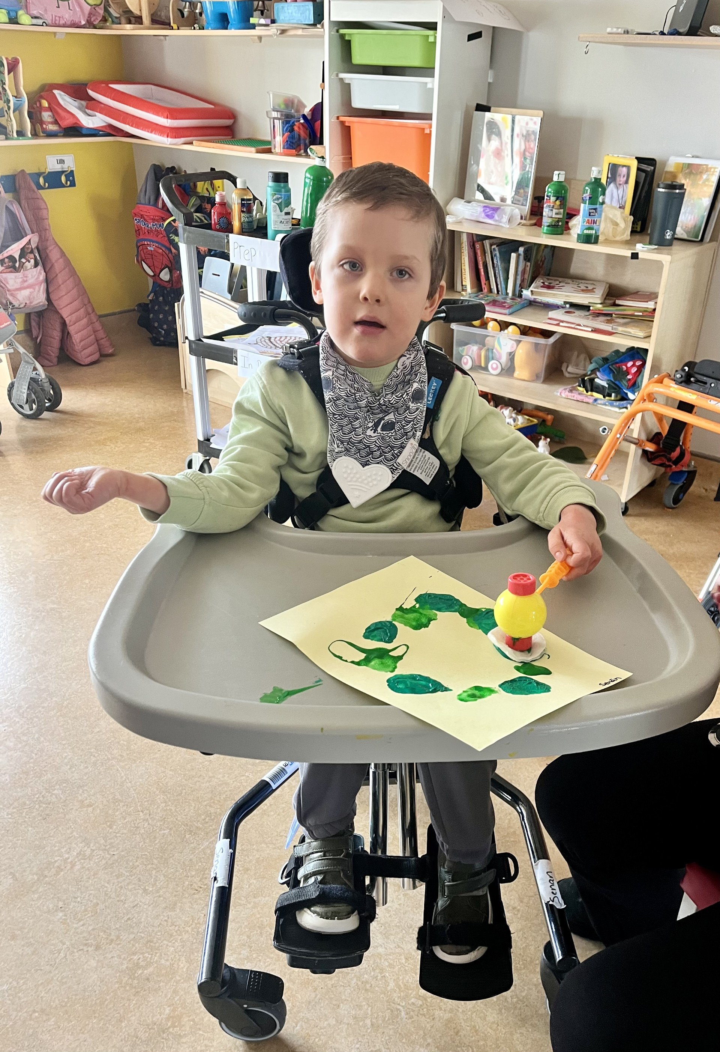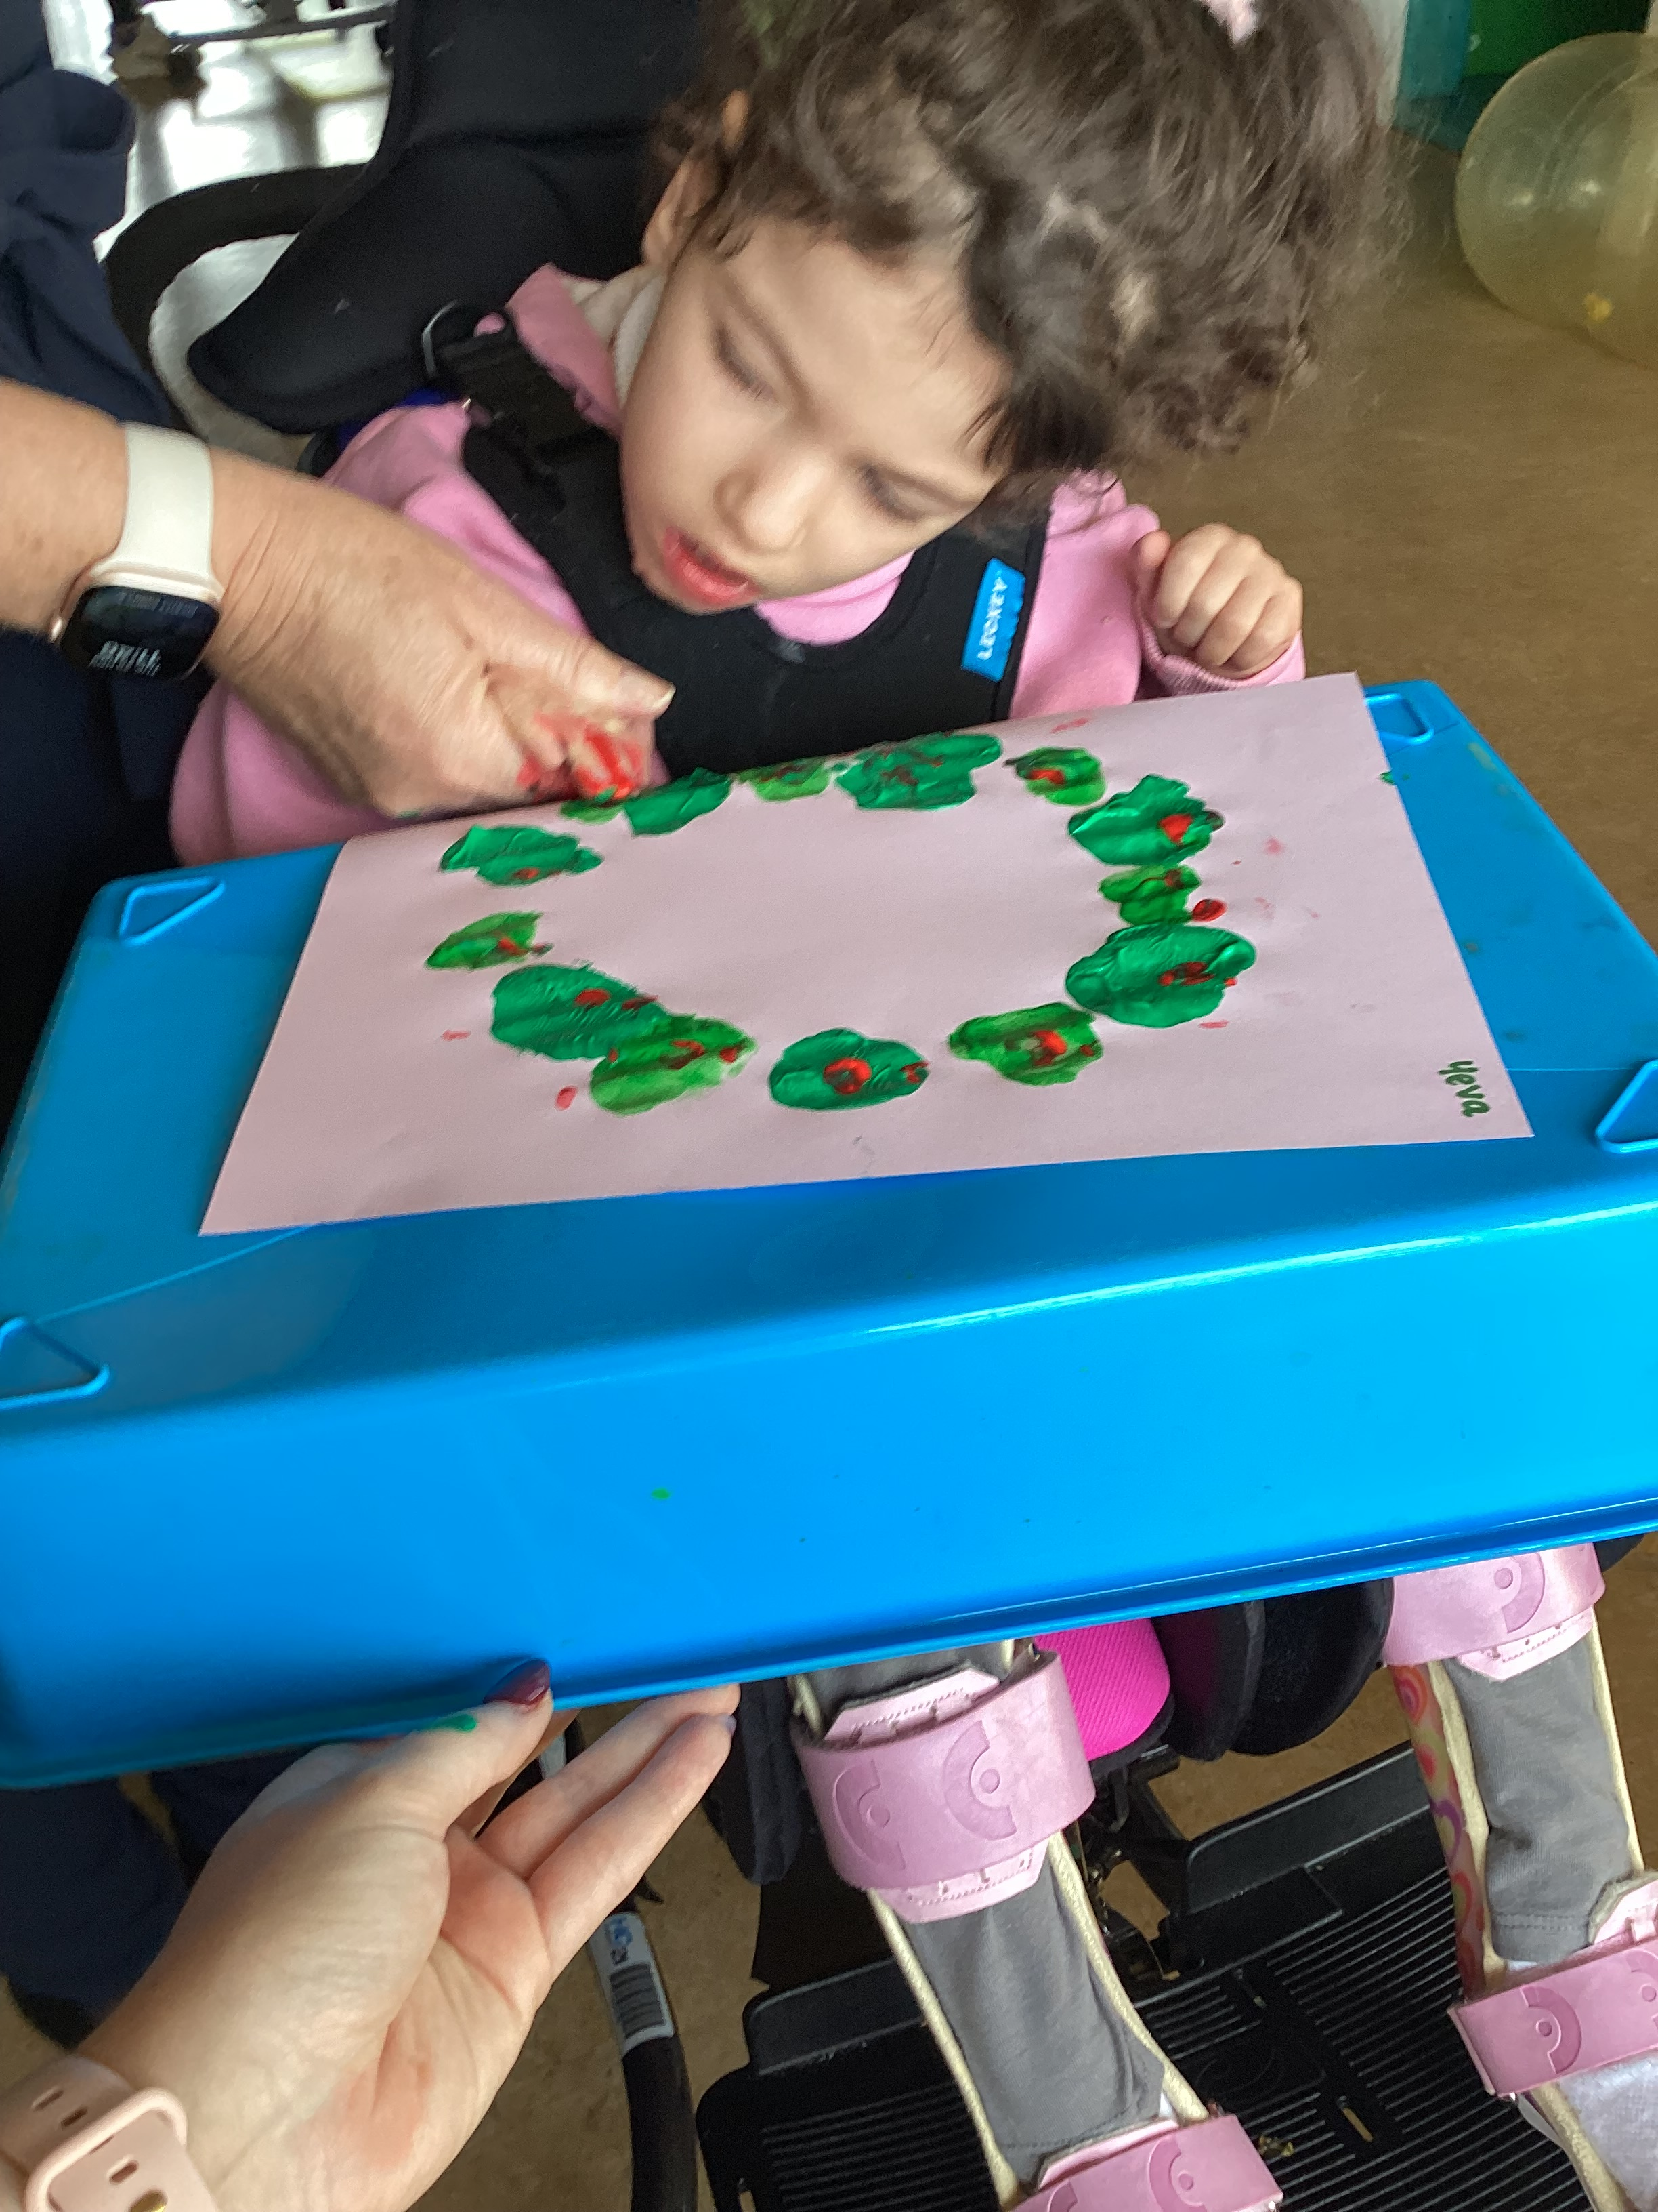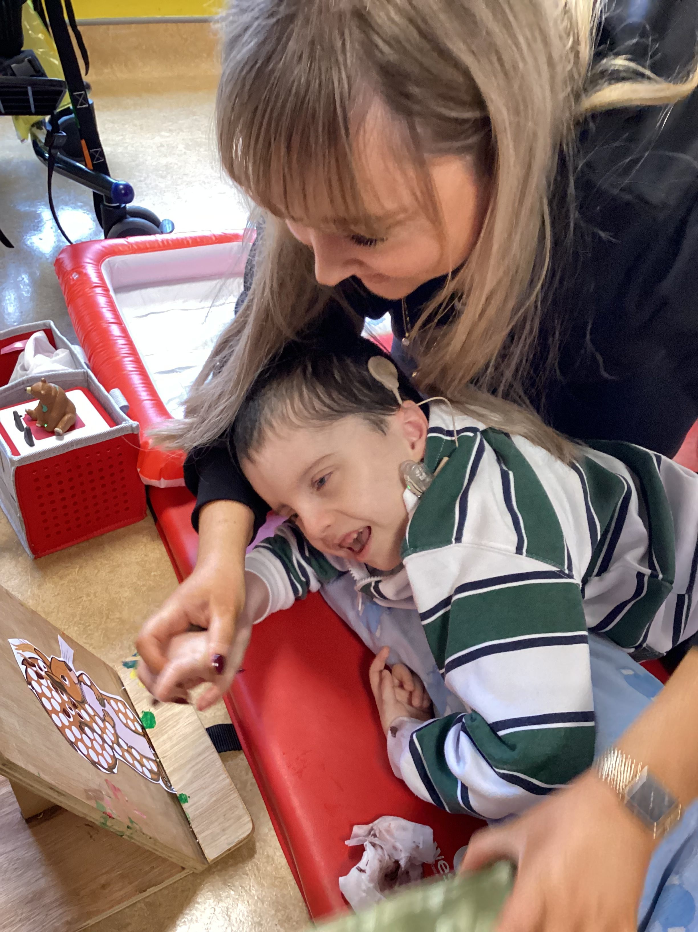
But, there is always time for relaxing with stories, tac pac and of course music
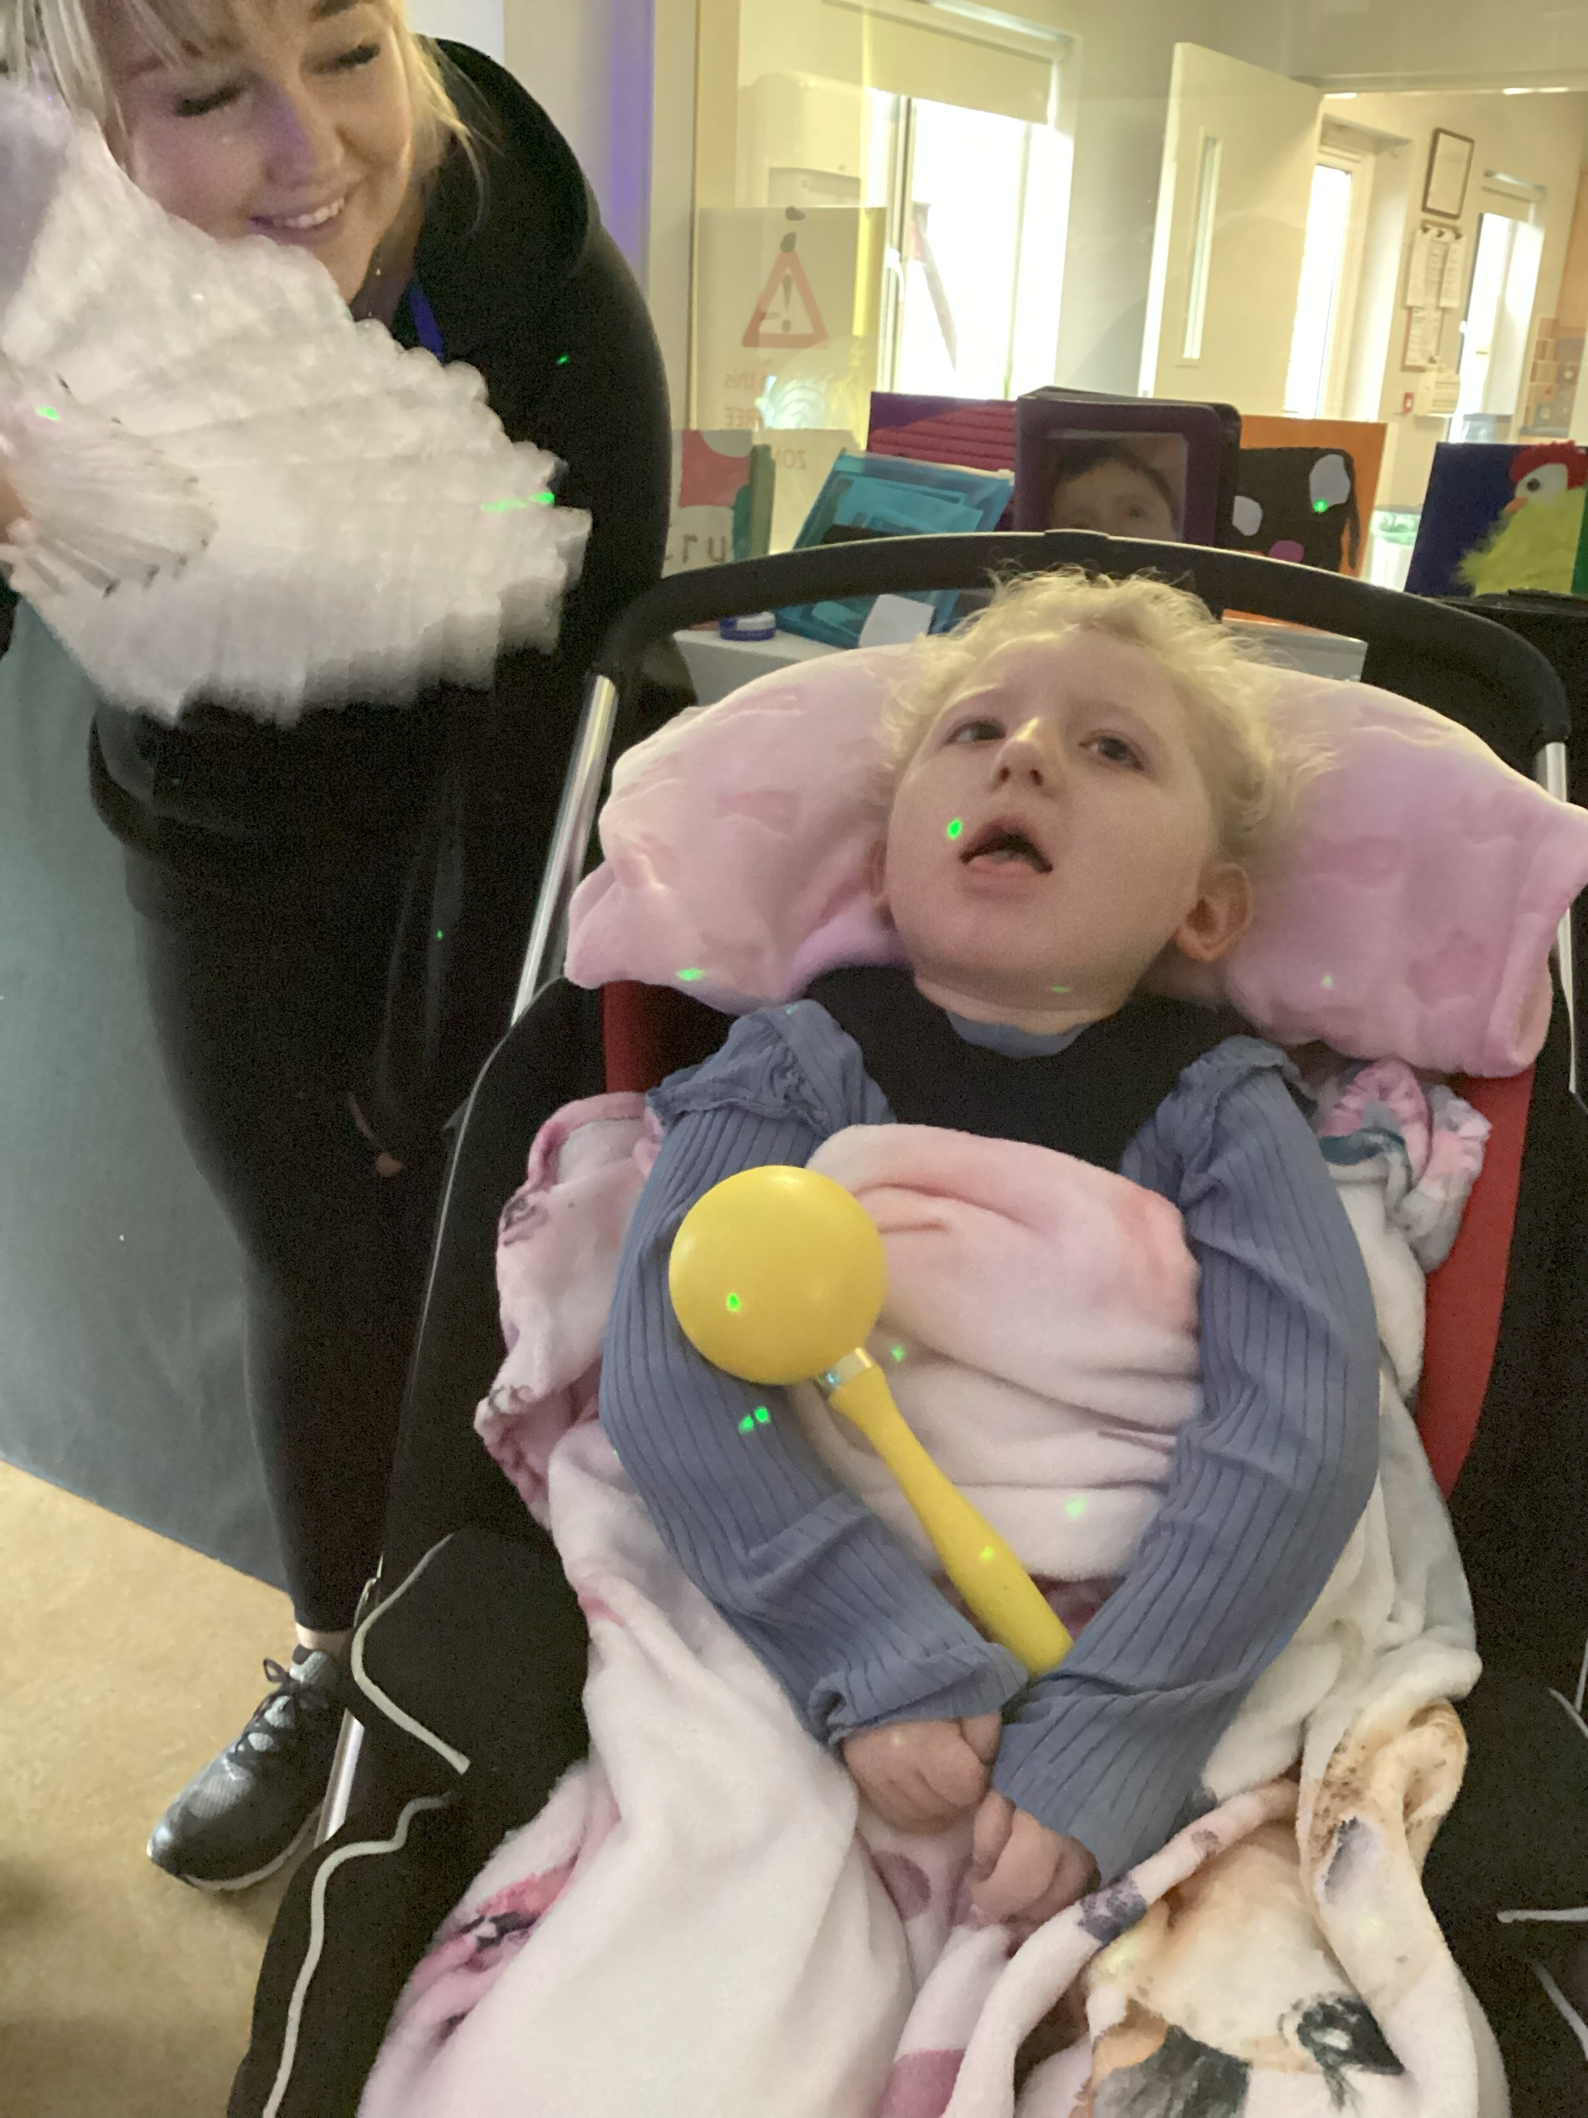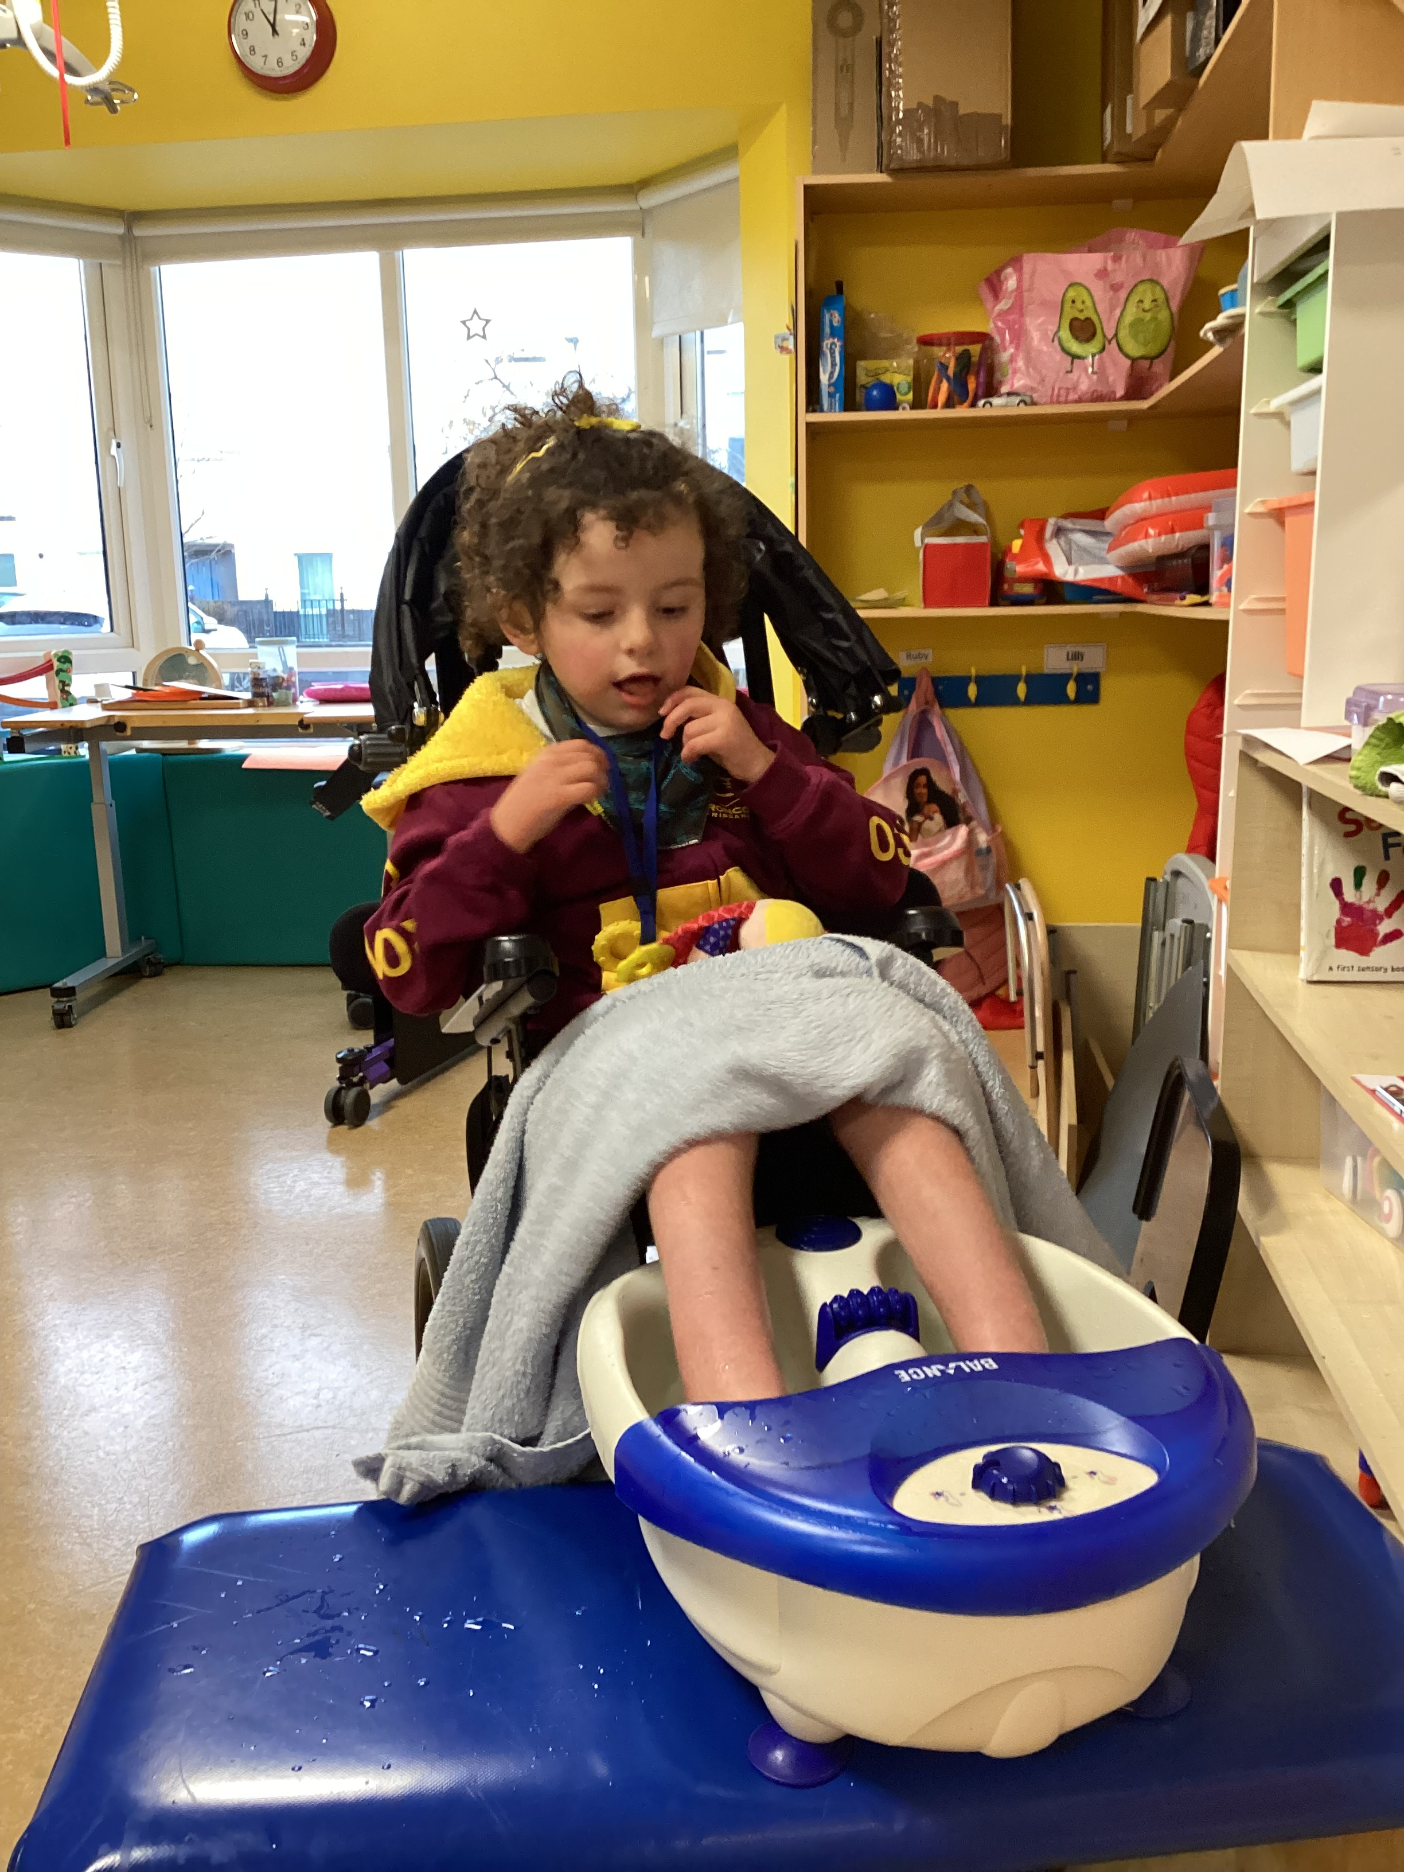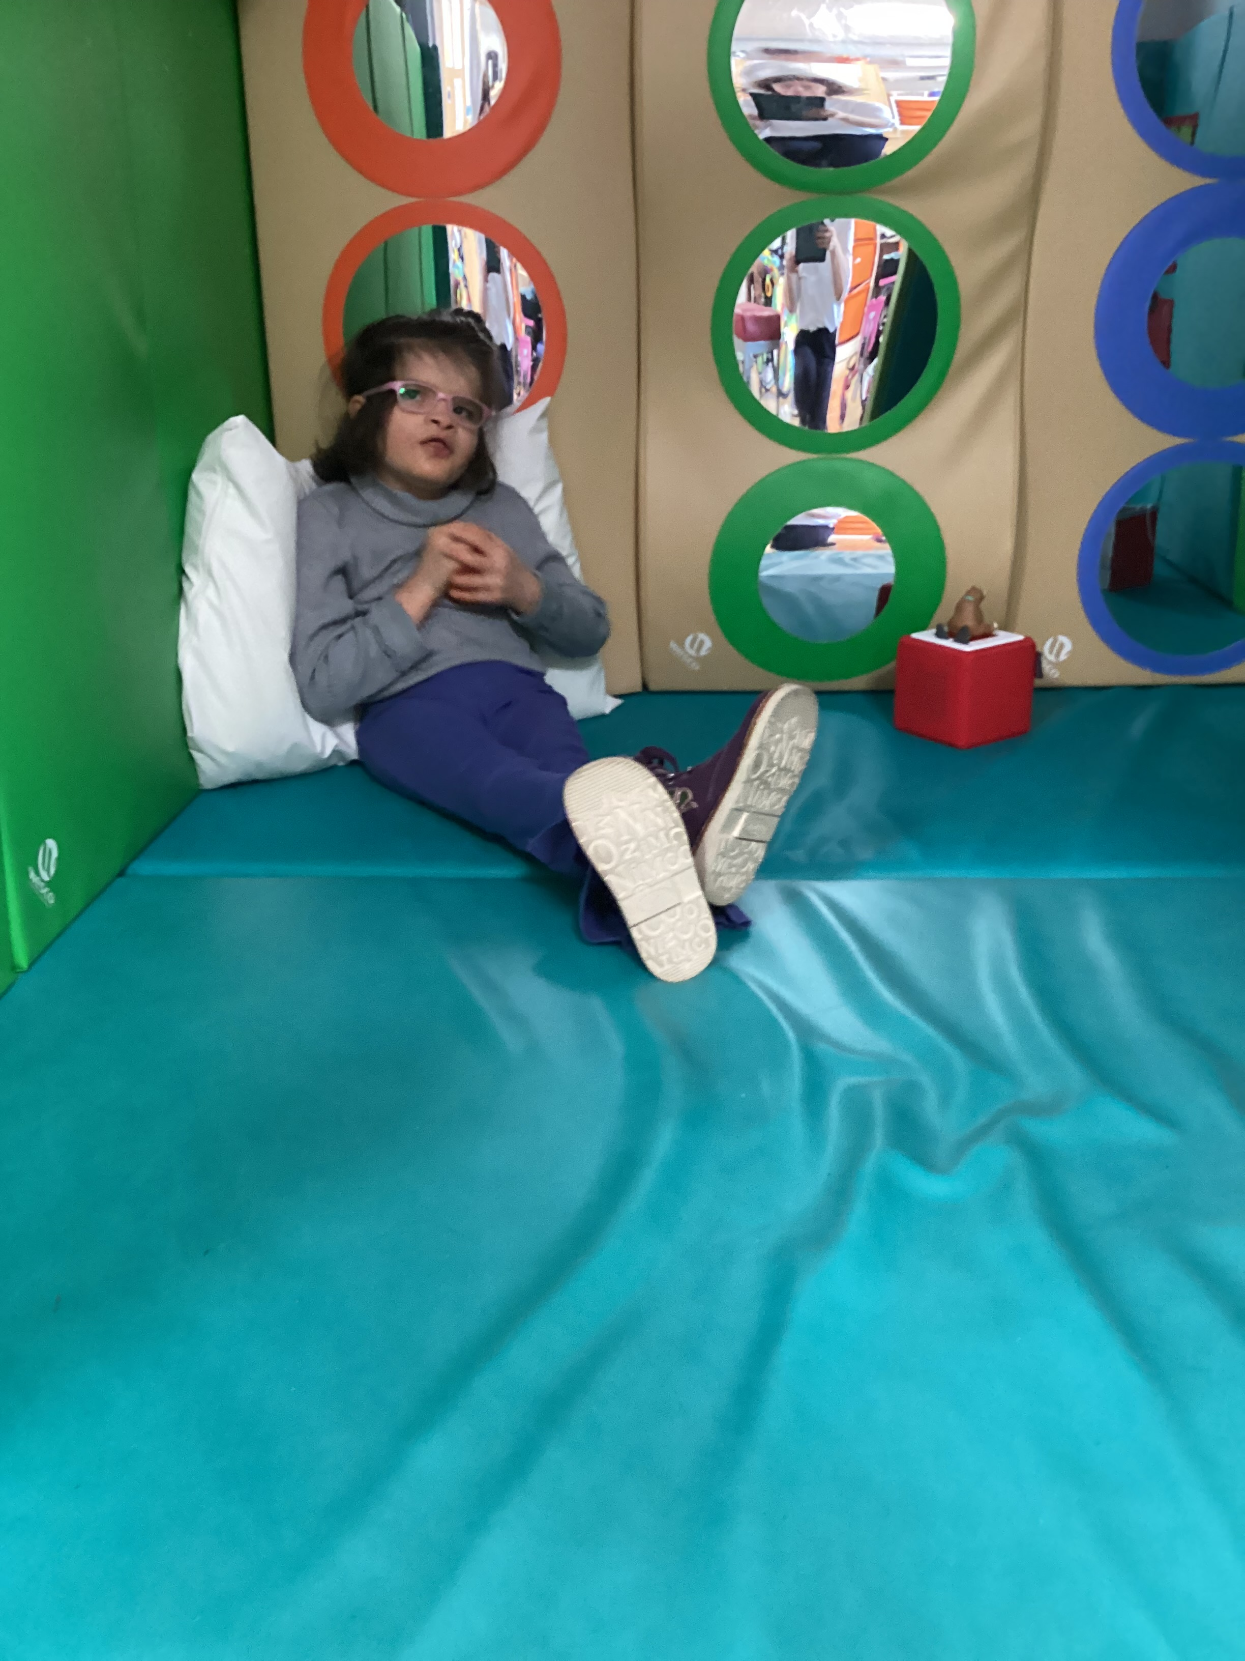

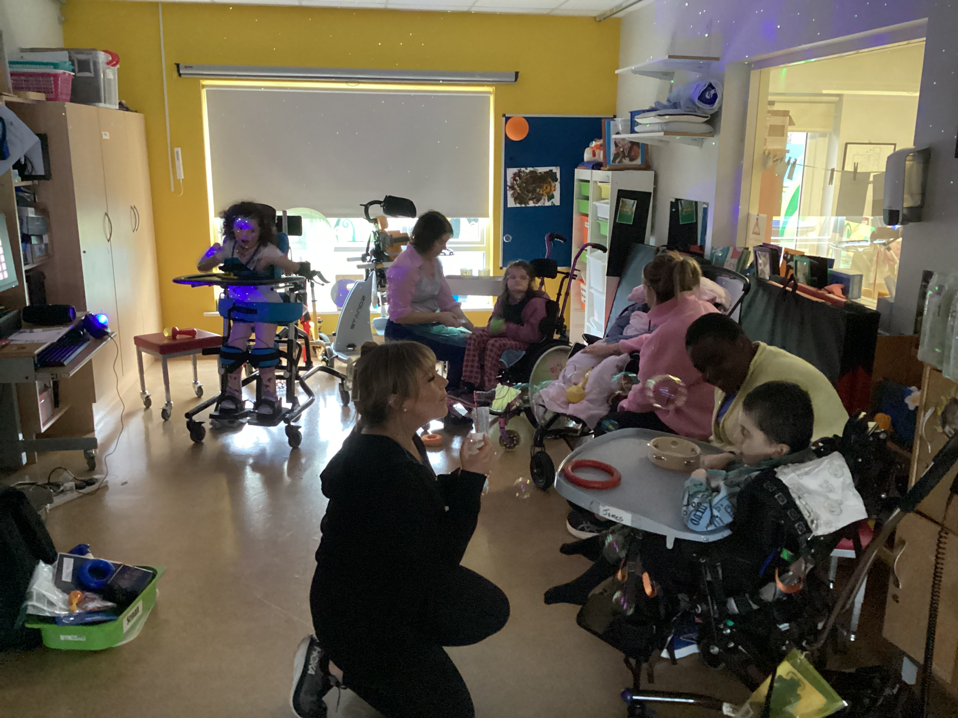

We are looking forward to another busy term ahead and already have plans for more outings and of course, lots of work!!

Wishing you all a very happy New Year, and always, thanking you all for your support.

Another Headline Here | You can easily change the formatting of selected text in the document text by choosing a look for the selected text from the Quick Styles gallery on the Home tab. On the Insert tab, the galleries include that are designed to coordinate with the overall look of your document. You can use these galleries to insert tables, headers, footers, lists, cover pages, and other document

